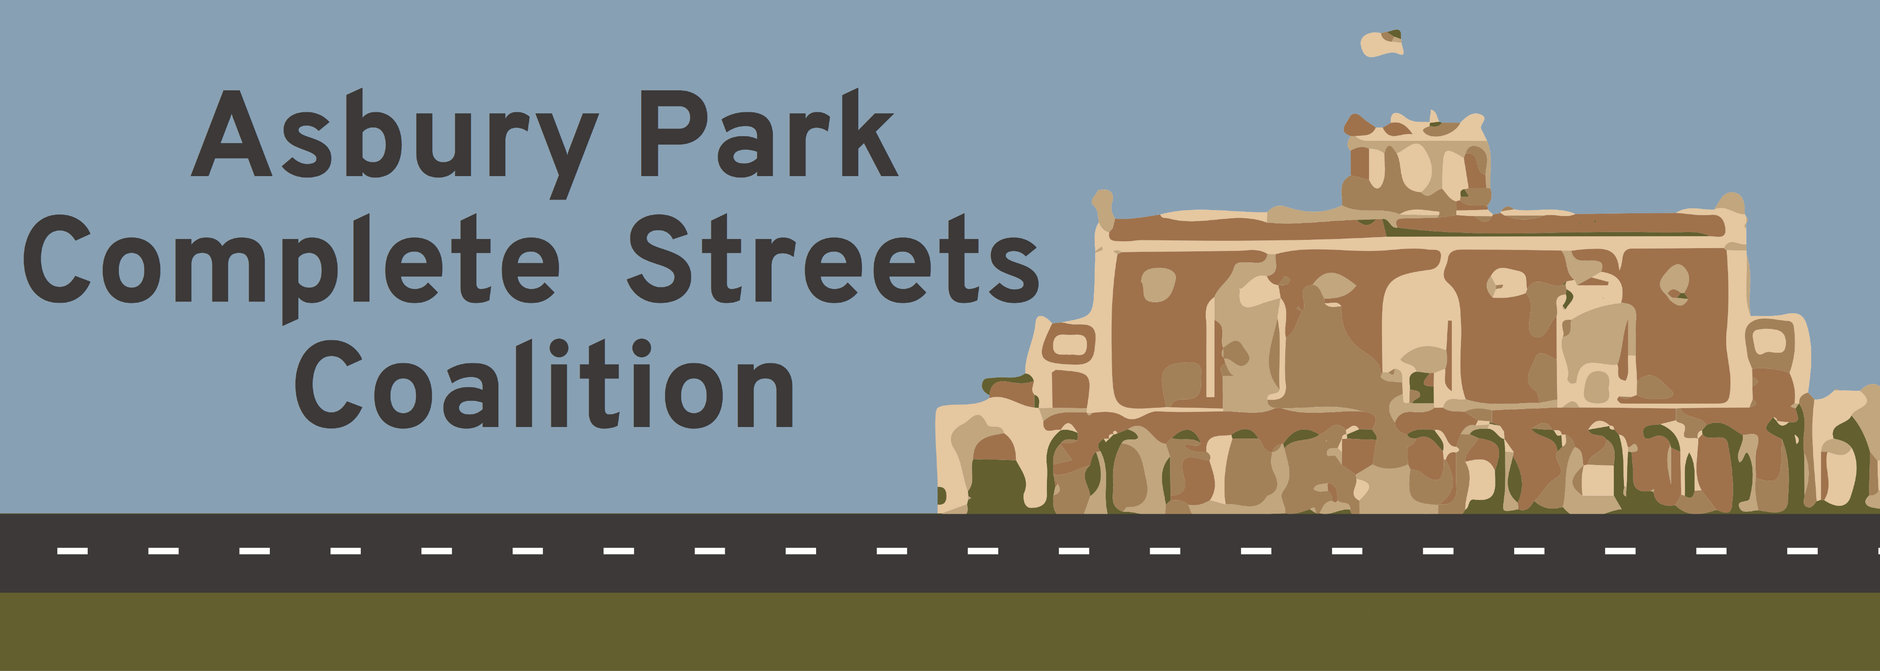
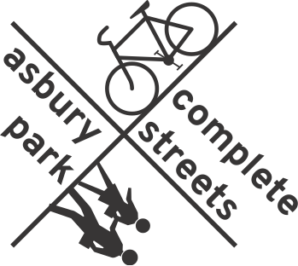

History
In the late summer of 2015 a small group of Asbury Park resident volunteers got together to help update the city’s bicycle code. A few weeks later the news broke that the mayor and city council had resolved to reject a NJDOT plan to reconfigure NJ Rt 71, our Main Street. This became our first initiative, and APCSC was born.

Part of the DOT reconfiguration plan included a “road diet”, a term that has less than pleasant connotations of restrictions and starvation, and the negative reaction by the city leaders and some residents was obvious. It seemed that prevailing opinion was that our Main Street needed to remain a 4-lane highway, and a thoroughfare to move cars as swiftly as possible through the city. As a group of walking and bicycling advocates we thought the NJDOT plan was great— a “no brainer” for safety, businesses, health, and equity. We believe that Main Street should be a destination to be arrived at, not a street to speed through on the way to another destination, and we were sure it should be a simple task to get everyone to agree. We began a barrage of information, research and evidence of the efficacy of a road diet at council meetings, in-person meet-ups, and on social media, and not surprisingly we encountered push-back. Some council members began to avoid us. Some administrators admonished us. We were branded “Wild-Eyed Fanatics” by the editor of a local paper. Some residents maintained threads on social media bashing the plan. We gradually learned that it would be a marathon, not a sprint, and that many cities have been working on Complete Streets issues for many years, so we began to refine our tactics.

We were not making many friends on city council and administration, perceived as hyper-engaged know-it-alls, but we were making friends elsewhere. We had researched traffic calming infrastructure, learned what other cities were doing successfully, how their road diet plans worked or didn’t work, and most importantly devised more effective ways to communicate with residents, with actions in addition to words. We found great support and direction from Cyndi Steiner of NJBWC. We reached out to local business owners and organizations such as AARP and Tri-State Transportation Campaign who gave their support on a letter to city council, and we garnered 500 signatures on a petition. We gave away bike lights, designed a logo, set up a Face Book page and a website, printed an infographic card and other informational material, including a research paper on the benefits of a road diet. We gained visibility riding bikes and walking in the St Pat’s parade with our banner, and hosted the documentary “Bikes vs. Cars” at sold-out screening at the Showroom Theater. We’ve met with other groups in the city such as the Homeowners Assoc., and the Historical Assoc. and set up a booth and information table on National Pride Day. We helped Safe Routes to Schools with Bike Rodeos and a school zone walkability assessment, and got a grant from NJ Natural Gas to buy portable bike racks to use as a bike valet at city events. We’ve attended the NJ Bike and Walk Summit in Princeton and participated on a panel with Paul Steely White of Transportation Alternatives at last year’s summit. APCSC has been hosting community bike rides throughout the city,
(which are now attended by the mayor, council members and our transportation manager) with the aim of bringing all neighborhoods of the city together.
Who we are now
APCSC started small in 2015 and has grown in numbers, background and diversity. We’re fortunate to have several members with urban planning background, recently one member was appointed to the Planning Board, one to the Zoning Board, and one elected to the School Board. The 2 Asbury Park bike shop owners are members, and other members bring their tech savvy, marketing and promotional skills, community organizing experience, and history of advocacy work. We’re all energetic and committed to Asbury Park becoming a city that provides streets that are safe for everyone, especially the most vulnerable—from 8-years old to 80-years old.

Asbury Park Complete Streets Coalition is now acknowledged as an entity in the city and in the state. APCSC has been honored with a nomination for the Complete Streets Champion Award, which will be awarded at the end of October at Rutgers University. The mayor and city council members are supportive, and even the editor of the local paper that called us Wild-Eyed Fanatics is now a fan! The city acknowledges the need to further the goals of the city’s existing Complete Streets Policy and hired a Transportation Manager who supports CS and has already has a significant list of accomplishments: a bike share program, bike corrals and bike racks, and bollards at crosswalks throughout the city, along with other important initiatives in the pipeline. Together we were involved in building a parklet on Cookman Ave for National Park(ing) Day in September. APCSC is involved in the city’s Bike and Pedestrian Master Plan, which will become the blueprint for change throughout the city.

Success and future
In May 2017, less than 2 years since rejecting the NJDOT plan for Main Street the Asbury Park City Council voted to rescind the resolution to reject the plan! Right now the city is working on the NJDOT reconfiguration of Main Street on a 2-year trial basis. The road diet component is paint— the width of the roadway will remain the same. Designated left turn lanes will help move traffic smoothly, crosswalks and traffic signals will be improved for pedestrian safety, and bike lanes will be included. We believe that residents, business owners and visitors will fully embrace the plan and see the benefits in safety, equity, economics, environment and health, making Rt 71 a true Main Street. There is the possibility that there may be naysayers and resistance to what may be perceived as slower movement of cars, so we’re prepared to continue the mission of Asbury Park Complete Streets Coalition. We will continue to work with the Mayor, City Council, administrators and the community to create streets throughout the city that are safe for everyone, especially the most vulnerable.

Asbury Park Complete Streets Coalition Mission Statement:
Streets are “complete” when they have safe access for all users – for pedestrians, bicyclists, the
elderly, the mobility challenged and drivers. Complete streets make it easy to safely cross the
street, walk to school, bicycle to work and stroll through healthy business districts, making
Asbury Park a better place to live. Our streets should be designed for all road users. Speed
endangers our most vulnerable citizens. Crashes cause pedestrian, bicyclist, and driver deaths.
www.apcompletestreets.org
Asbury Park Complete Streets Coalition

@AsburyParkCSC

